ROYAL OAK INTERNATIONAL SCHOOL
SR. SEC. CBSE AFFILIATED
HOLIDAY HOME WORK (SESSION 2018-19)
Class - III
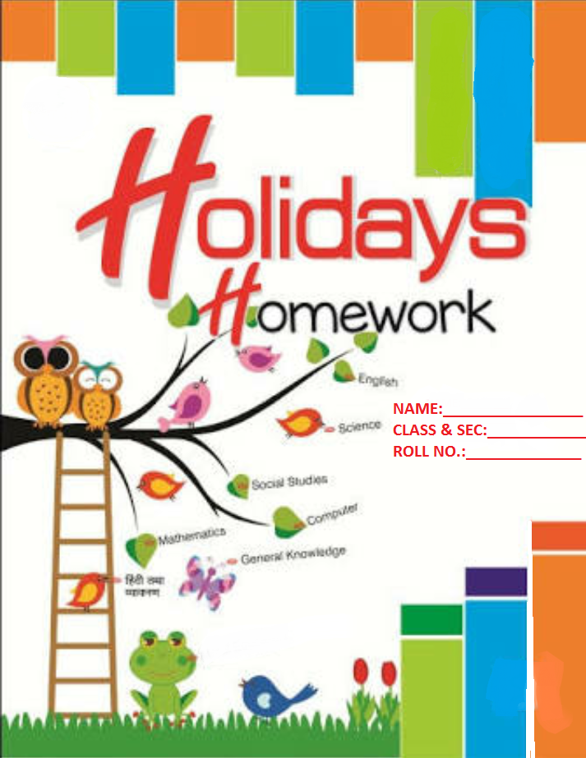
Please note the following:
- Summer vacations will commence from
17th May, 2018(Thursday) till 29th June,2018(Friday).
[Both date inclusive]
- The school will re-open on 2nd July, 2018(Monday).
- HHW of 5 marks will be added as an activity marks in Term I.
- Schedule for the submission of HHW for all classes is as follows:

English : 9/07/2018
Hindi/S.St : 10/07/2018
Math : 11/07/2018
Science : 12/07/2018
Comp/G.K. : 2nd week of July

Wishing you all a very Fruitful and Enjoyable vacations. HAPPY HOLIDAY!

FOR THE PARENTS

Summer Vacations are here. A few vital suggestions are listed below to make the vacations more exciting and fruitful than ever before:
- Keep at least half an hour a day for sharing experiences with your child.
- Encourage your child to speak in English. Fix one hour in a day when you communicate with your child only in English.
- Tell your child different stories regularly and encourage him/her to describe what he/she would do in a similar situation. Here are few suggested titles which you can read with your child.
a. Hare and the Tortoise d. Emperor’s New Clothes
b. Thumbelina e. Cinderella Fairy tell (story book)
c. Panchatantra stories
- Let your child colour, draw, paint, Play , Dance etc.
- Restrict his/her television watching, confining it to interesting children’s program, cartoon films, discovery channel etc.
- To improve the formation of letter, make your child write a page every day.
- Develop self helpskills : Let your child dress and feed on his/her own.
- Make him/her understand the importance of cleaning his/her room and putting away toys and belongings after use.
- Take your child out for picnics and to other places of his/her interest. Ask him/her to make a note of all the places he/she visits and things he/she sees so that he/she is able to discuss his/her experience in class after vacations.
Have a nice time!
PRINCIPAL

ENGLISH:
- Read a story book (Diary of wimpy kid / Charlie and chocolate factory/Matilda/ of your own choice. Choose the character you like the most from the story. Fold a half a chart paper like a greeting card & write few sentences about that character on it. Draw or paste colourful pictures from the story on the front page.

- Make a beautiful chart of common/proper/collective and compound noun with pictures.

- Collect information about the different rivers and write it on A4 sheet.

- Pick any two new words ( from story books / newspaper ) daily and make your own dictionary creatively.(A to Z)

HINDI:
- ikB Uk0 1 & 3 rd ds iz0@m0 ] dfBu “kCn “kCnkFkZrFkkiqLrdvH;kl ;kndjks A
- ,d 10 -15iafDr;ksa dh ,d vPNhdfork;kndjsrFkkmls ,dA- 4 Size Sheet ijfy[kdjyk,¡ A
- o.kksZa ¼Loj vkSjO;atu ½ dh ,d lqanjekyk cuk,¡A¼xksykdkj vkd`fresapkVZisijdksdkVdjLojvkSjO;atu dh ekyk cuk,¡½
- fn, x, ladsr&fcanqvksa ds vk/kkjij 5 &6 okD;ksaesafyf[k, fdtydSlsnwf’krgksrkgSA
- QSfDVª;ksadkxankikuh unh esaMkyuk
- Ik”kqvksadksugykuk
- unh esadwM+kQsaduk
A – 4 lkbt “khVijfp= lfgrcuk,¡ A
MATH:
Make a thin notebook and do the following homework in it.
1. Solve the given worksheet
2. Write the counting from 1101 to 1500 with number names.
3. Learn and write tables from 2 to 15 .
4. Do page no. 34 to 38,58 to 60.
5. Revise PA 1 Syllabus.
SCIENCE:
.Read and Learn ch-2, 3 and 6 (Book Ex. And Note book work)
2.Paste pictures of at least three living things and three non living things whose name start with the following letters A,D,F,H,M,ST.(Roll no. 1 to 15)
3. Paste different type of original fabric on A3 sheet and write from where do we get.(Roll no.16 to30)
4.Grow seedless plant eg.money plant,rose plant etc. of your own choice during your holidays.
S.ST.:
1. Revise all the work done in the note book and book.
2. Collect pictures of Monuments of Delhi and make a collage on A-3 Sheet with their names. (R. NO.-1-15)
3.Collect pictures of sources of water and paste them on A-4 sheet. (R.NO.-16 -30)
4.Collect pictures and information about the following astronauts and write few lines about them on flash cards.
a)Rakesh Sharma b)KalpanaChawla C)Sunita Williams

COMPUTER:
- Do Page no. 14, 23 and 87 in book.
- Read and Learn chapter 1 , 2 and 8
- Draw different tools of Tux Paint window in computer notebook and name them with their uses.
- Draw Pictures related to topic mentioned below on A3 sheet.
  - Roll No. 1-10 Tux Paint Screen(Refer Pg-73)
  - Roll No. 11-20 Basic parts of Desktop Computer (Refer Pg-15).
  - Roll No. 21 onwards Make a collage of Internal parts of computer (Refer Pg-17)
- Collect some pictures of Monitor, CPU, Keyboard, CD/DVD drive and Printers from Newspaper and Magazines and paste them in your computer notebook with their names.
- Do the given worksheet.

G.K. :
1. Read the newspaper daily and write two main important headlines every day, with one Sports news and paste the related pictures in G.K. notebook. (From ${21}^{st}$ May to $5^{th}$ June 2018)
2. a. India is a country having people of different faiths and religions. People celebrate different festivals on different occasions. In some states when the crops are ready for harvesting, people celebrate this time as the harvesting festivals. Paste the pictures of harvesting festivals of different states and mention their names also. (Refer to Page No. 31) (Roll No. 1-15)
b. Paste 5 pictures of Historical Monuments; mention their names, places and states on A3 Size Sheet. (Roll No. 16 onwards)
3. Draw /paste the picture of a tree in your G.K. notebook and write six sentences on the topic “Importance of Trees”.

ART &CRAFT:
Pen Holder with Plastic Bottle.

